Data

Definition
# Source: AI Source: Provided by: [Data Path: Persons Table -> ID Column: 1, Name_En Column: Motasem Essam] -> From: [ChatGPT] on [4/22/2026]
Data are raw facts, figures, or observations that have not yet been processed or given meaning.

The basic idea
# Source: AI Source: Provided by: [Data Path: Persons Table -> ID Column: 1, Name_En Column: Motasem Essam] -> From: [ChatGPT] on [4/22/2026]
Data is the starting point—before any interpretation or analysis happens.

Simple examples
# Source: AI Source: Provided by: [Data Path: Persons Table -> ID Column: 1, Name_En Column: Motasem Essam] -> From: [ChatGPT] on [4/22/2026]
- Numbers: 45, 100, 3.14
- Words: “apple”, “blue”, “student”
- Measurements: temperature readings, test scores
- Symbols or signals: clicks, images, sounds
By themselves, these don’t explain much—they’re just pieces of information waiting to be understood.

Data vs Information
# Source: AI Source: Provided by: [Data Path: Persons Table -> ID Column: 1, Name_En Column: Motasem Essam] -> From: [ChatGPT] on [4/22/2026]
- Data: “25, 30, 28”
- Information: “The average temperature over three days is 27.7°C”

Types of data
# Source: AI Source: Provided by: [Data Path: Persons Table -> ID Column: 1, Name_En Column: Motasem Essam] -> From: [ChatGPT] on [4/22/2026]
- Qualitative data: descriptive (colors, names, categories)
- Quantitative data: numerical (counts, measurements)

1. Qualitative Data (Descriptive Data)
# Source: AI Source: Provided by: [Data Path: Persons Table -> ID Column: 1, Name_En Column: Motasem Essam] -> From: [ChatGPT] on [4/22/2026]
Qualitative data describes qualities or characteristics rather than numbers.
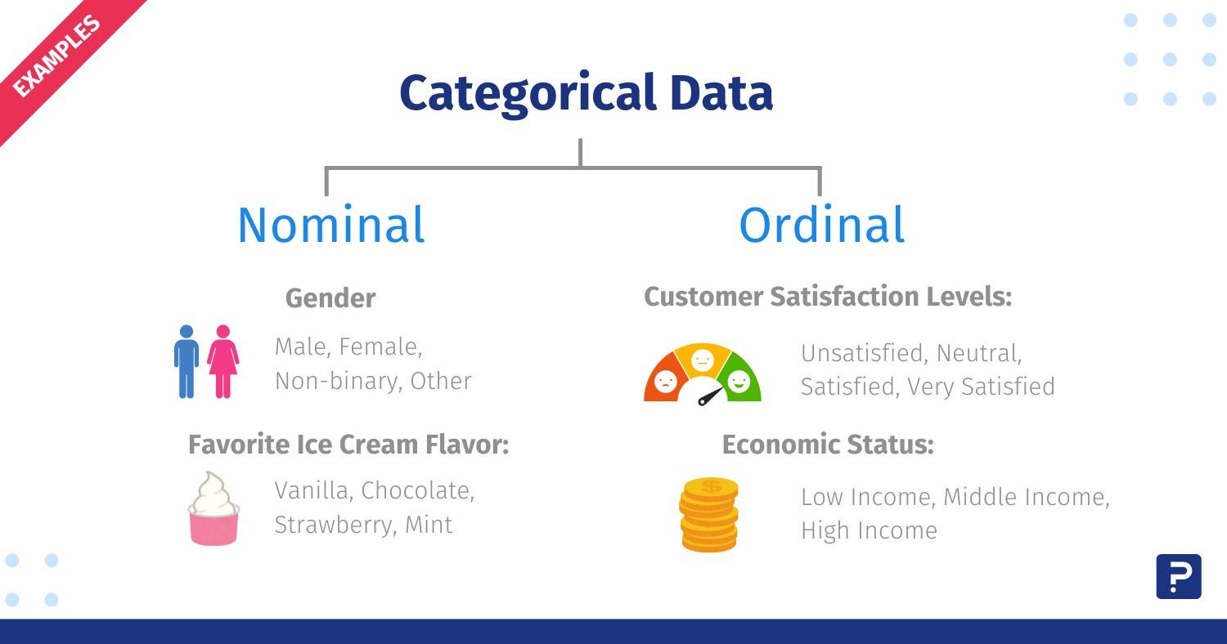
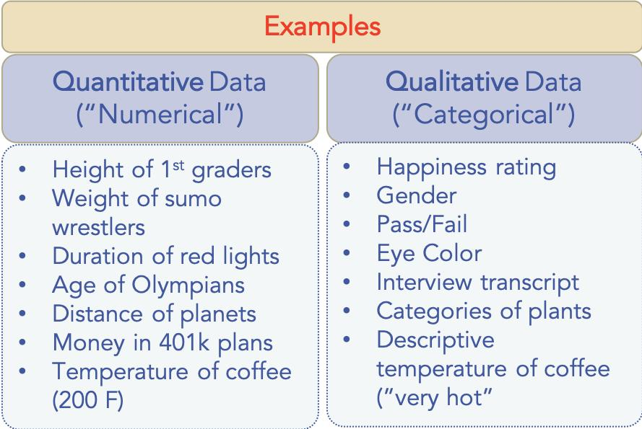
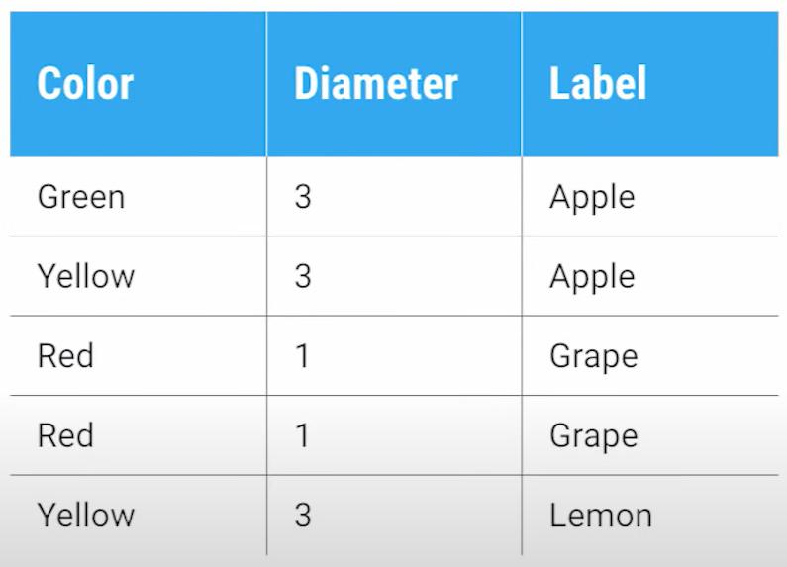

What it means
# Source: AI Source: Provided by: [Data Path: Persons Table -> ID Column: 1, Name_En Column: Motasem Essam] -> From: [ChatGPT] on [4/22/2026]
This type of data answers questions like:
- What kind?
- Which category?
- What type?

Examples
# Source: AI Source: Provided by: [Data Path: Persons Table -> ID Column: 1, Name_En Column: Motasem Essam] -> From: [ChatGPT] on [4/22/2026]
- Colors: red, blue, green
- Names: Ahmed, Sara
- Categories: male/female, yes/no
- Opinions: happy, satisfied, unhappy

Types of qualitative data
# Source: AI Source: Provided by: [Data Path: Persons Table -> ID Column: 1, Name_En Column: Motasem Essam] -> From: [ChatGPT] on [4/22/2026]
- Nominal: no order (e.g., colors, names)
- Ordinal: has order (e.g., small, medium, large)

1. Nominal Data (No Order)
# Source: AI Source: Provided by: [Data Path: Persons Table -> ID Column: 1, Name_En Column: Motasem Essam] -> From: [ChatGPT] on [4/22/2026]
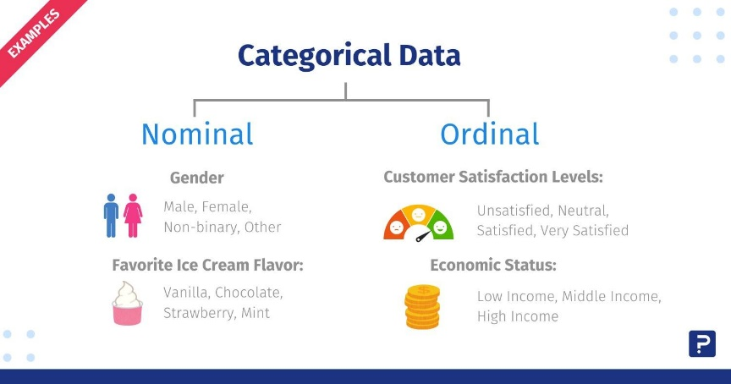
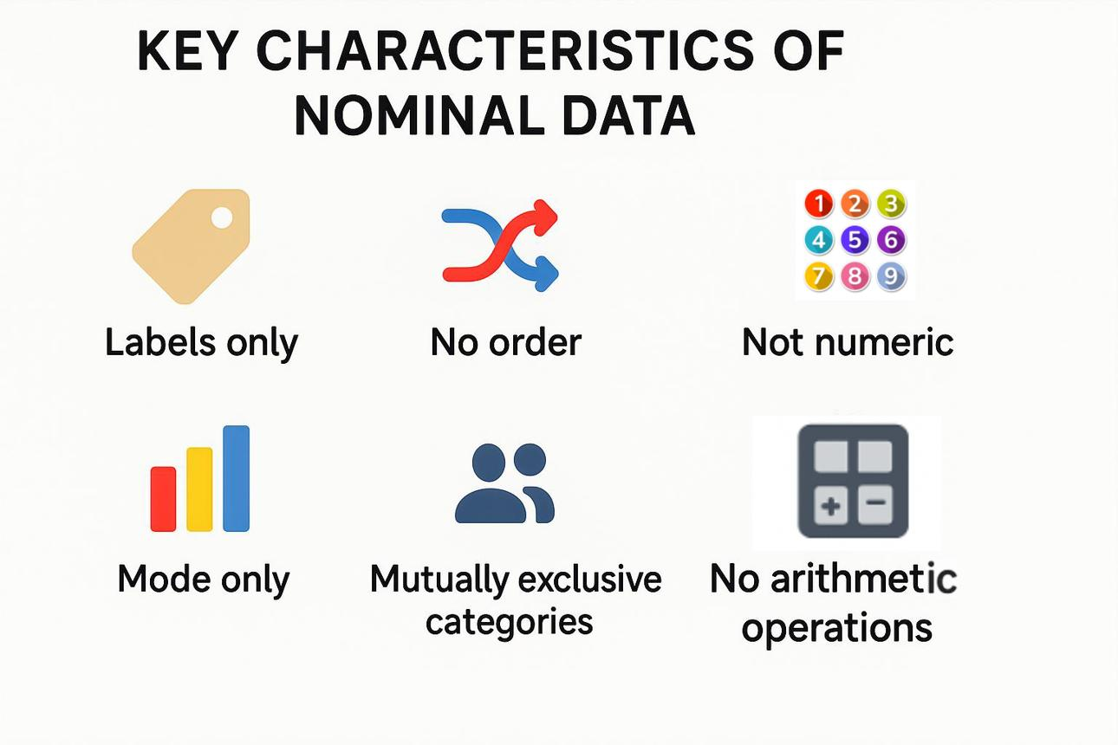
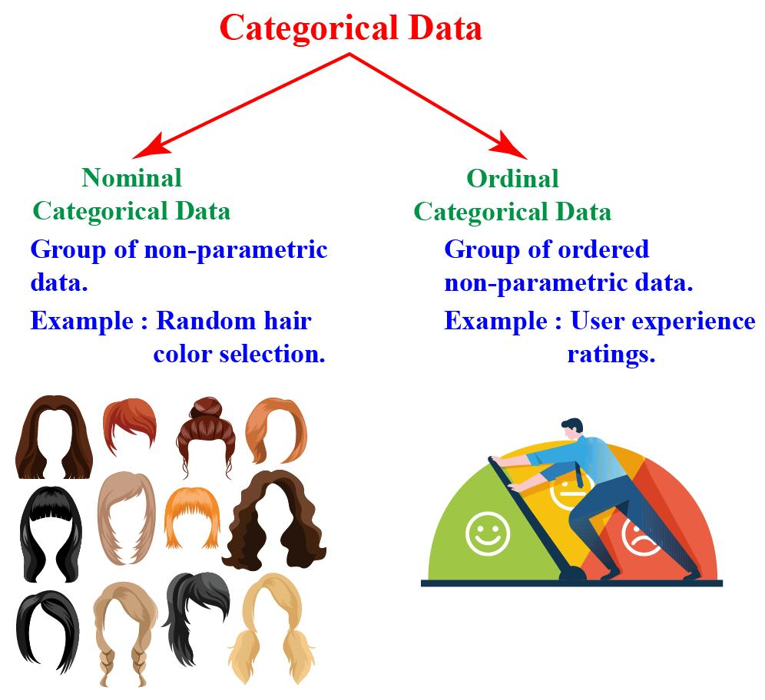

What it means
# Source: AI Source: Provided by: [Data Path: Persons Table -> ID Column: 1, Name_En Column: Motasem Essam] -> From: [ChatGPT] on [4/22/2026]
Nominal data consists of categories or labels that have no natural order or ranking.

Examples
# Source: AI Source: Provided by: [Data Path: Persons Table -> ID Column: 1, Name_En Column: Motasem Essam] -> From: [ChatGPT] on [4/22/2026]
- Colors: red, blue, green
- Gender: male, female
- Types of food: pizza, rice, pasta
- Names of cities or people

Key features
# Source: AI Source: Provided by: [Data Path: Persons Table -> ID Column: 1, Name_En Column: Motasem Essam] -> From: [ChatGPT] on [4/22/2026]
- Used for naming or labeling only
- No ranking (you can’t say one is “greater” or “less”)
- Numbers, if used, are just labels (e.g., 1 = male, 2 = female)
👉 You cannot logically arrange nominal data from highest to lowest.

2. Ordinal Data (Has Order)
# Source: AI Source: Provided by: [Data Path: Persons Table -> ID Column: 1, Name_En Column: Motasem Essam] -> From: [ChatGPT] on [4/22/2026]
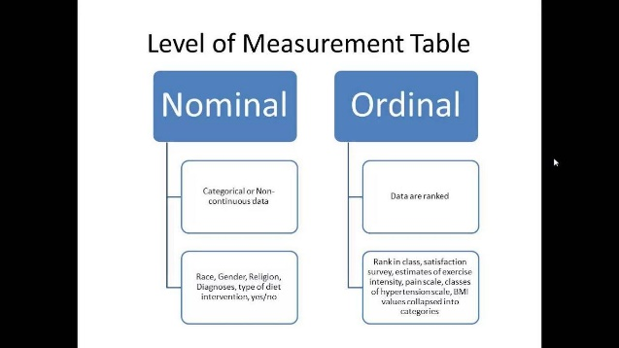
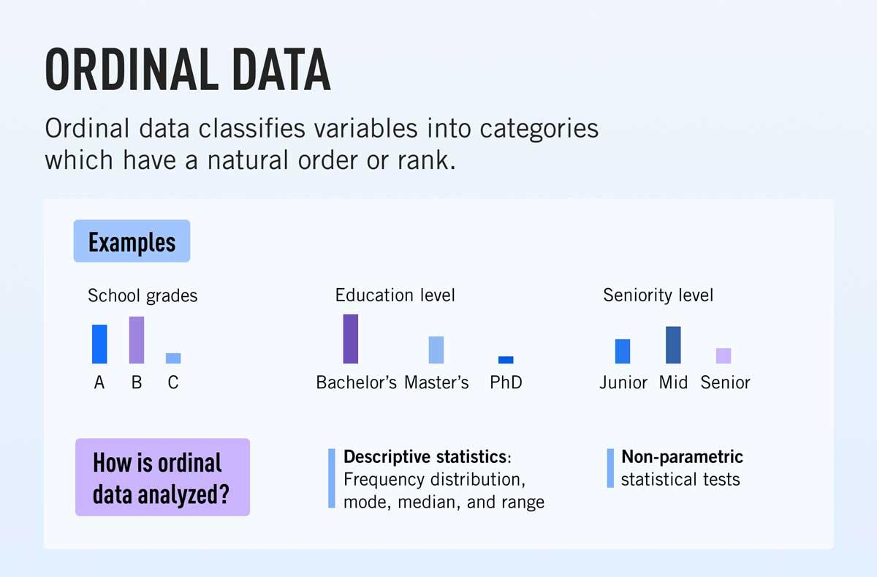
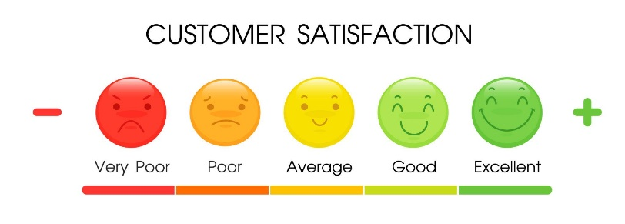

What it means
# Source: AI Source: Provided by: [Data Path: Persons Table -> ID Column: 1, Name_En Column: Motasem Essam] -> From: [ChatGPT] on [4/22/2026]
Ordinal data consists of categories that can be placed in a meaningful order or ranking.

Examples
# Source: AI Source: Provided by: [Data Path: Persons Table -> ID Column: 1, Name_En Column: Motasem Essam] -> From: [ChatGPT] on [4/22/2026]
- Sizes: small, medium, large
- Rankings: 1st, 2nd, 3rd
- Satisfaction levels: low, medium, high
- Survey responses: strongly agree → strongly disagree

Key features
# Source: AI Source: Provided by: [Data Path: Persons Table -> ID Column: 1, Name_En Column: Motasem Essam] -> From: [ChatGPT] on [4/22/2026]
- Has a clear order or sequence
- The difference between levels is not measurable (we don’t know how much bigger “large” is than “medium”)
- Useful for comparisons like higher/lower or better/worse
👉 You can rank ordinal data, but you can’t measure exact differences between categories.

Main Difference
# Source: AI Source: Provided by: [Data Path: Persons Table -> ID Column: 1, Name_En Column: Motasem Essam] -> From: [ChatGPT] on [4/22/2026]
- Nominal → categories with no order
- Ordinal → categories with a meaningful order

Key features
# Source: AI Source: Provided by: [Data Path: Persons Table -> ID Column: 1, Name_En Column: Motasem Essam] -> From: [ChatGPT] on [4/22/2026]
- Not expressed as numbers (though sometimes coded as numbers)
- Focuses on description and classification
- Cannot be meaningfully added or averaged

2. Quantitative Data (Numerical Data)
# Source: AI Source: Provided by: [Data Path: Persons Table -> ID Column: 1, Name_En Column: Motasem Essam] -> From: [ChatGPT] on [4/22/2026]
Quantitative data represents quantities and numbers—things you can measure or count.
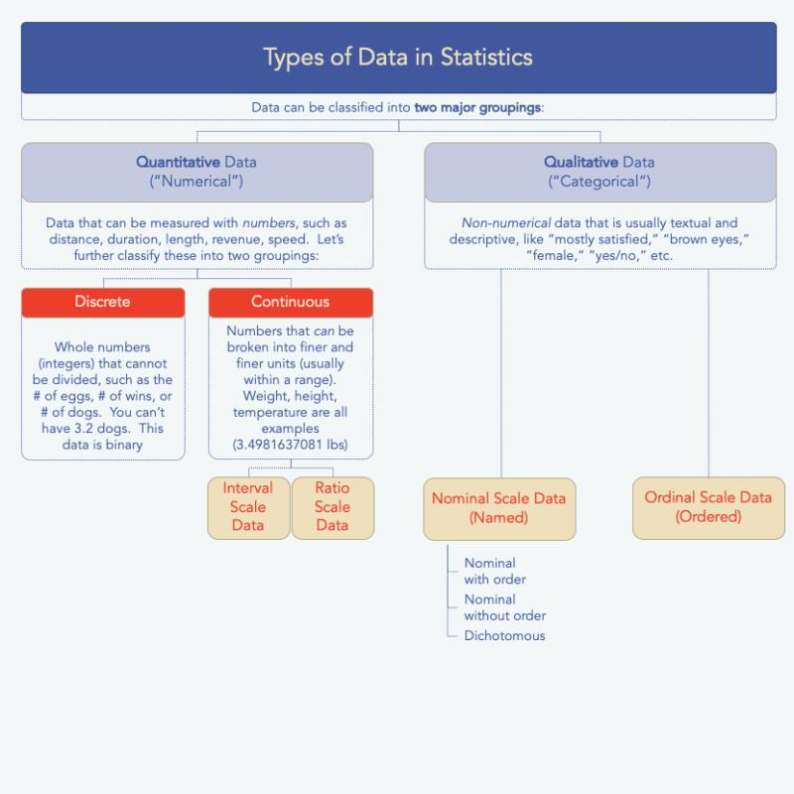
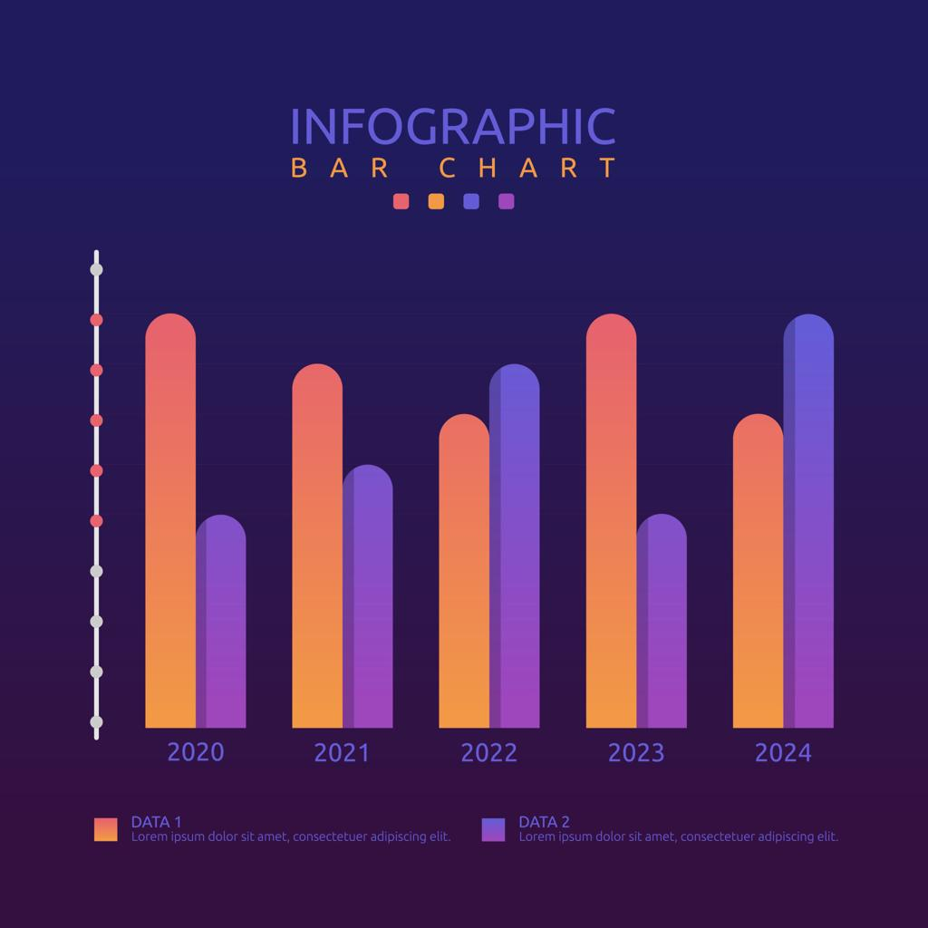

What it means
# Source: AI Source: Provided by: [Data Path: Persons Table -> ID Column: 1, Name_En Column: Motasem Essam] -> From: [ChatGPT] on [4/22/2026]
This type of data answers questions like:
- How many?
- How much?
- How often?

Examples
# Source: AI Source: Provided by: [Data Path: Persons Table -> ID Column: 1, Name_En Column: Motasem Essam] -> From: [ChatGPT] on [4/22/2026]
- Age: 20 years
- Height: 170 cm
- Number of students: 30
- Temperature: 25°C

Types of quantitative data
# Source: AI Source: Provided by: [Data Path: Persons Table -> ID Column: 1, Name_En Column: Motasem Essam] -> From: [ChatGPT] on [4/22/2026]
- Discrete: countable numbers (e.g., number of students = 25)
- Continuous: measurable values (e.g., weight = 65.5 kg)

1. Discrete Data (Countable Values)
# Source: AI Source: Provided by: [Data Path: Persons Table -> ID Column: 1, Name_En Column: Motasem Essam] -> From: [ChatGPT] on [4/22/2026]
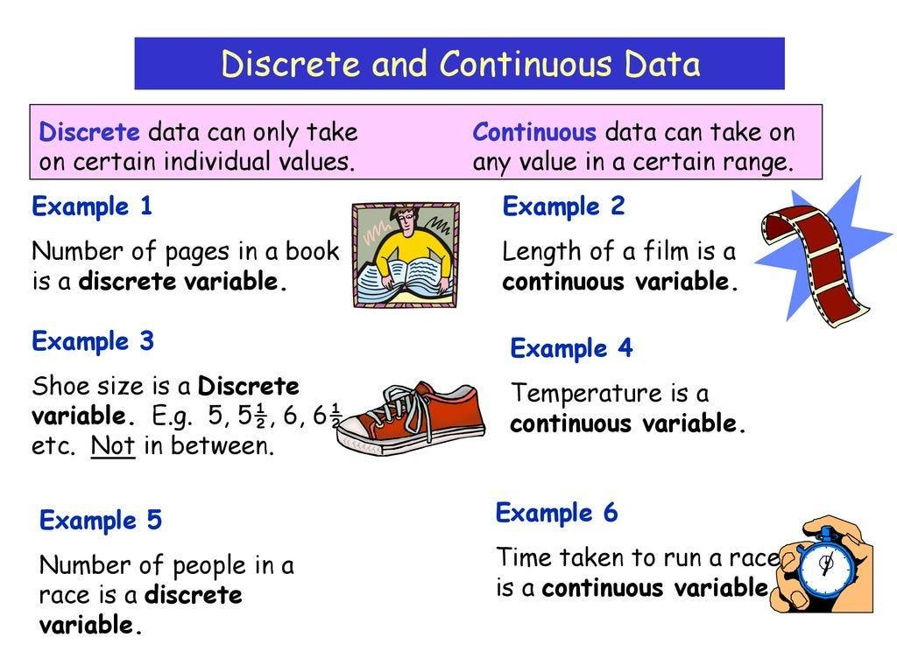
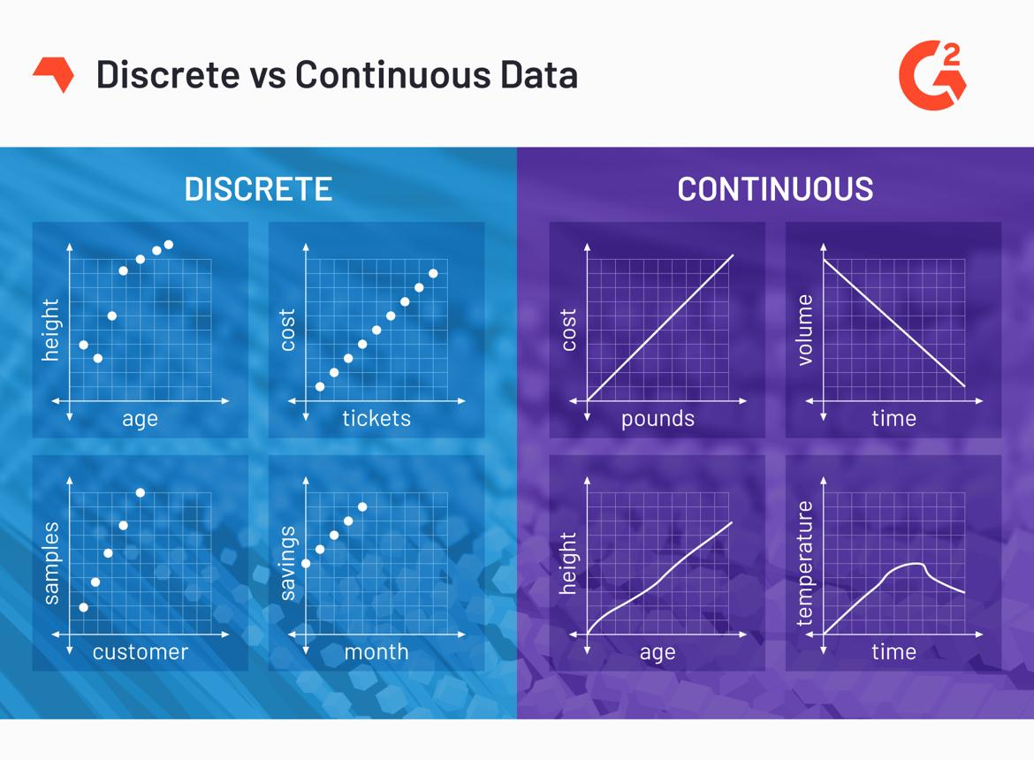
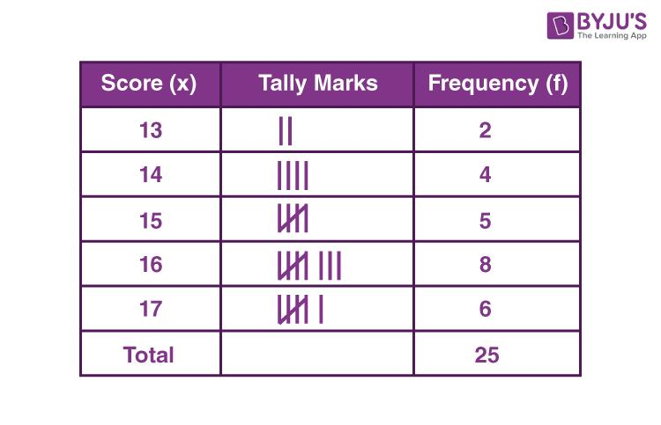

What it means
# Source: AI Source: Provided by: [Data Path: Persons Table -> ID Column: 1, Name_En Column: Motasem Essam] -> From: [ChatGPT] on [4/22/2026]
Discrete data consists of separate, distinct values that can be counted.

Examples
# Source: AI Source: Provided by: [Data Path: Persons Table -> ID Column: 1, Name_En Column: Motasem Essam] -> From: [ChatGPT] on [4/22/2026]
- Number of students in a class: 25
- Number of cars in a parking lot: 40
- Number of books on a shelf: 12

Key features
# Source: AI Source: Provided by: [Data Path: Persons Table -> ID Column: 1, Name_En Column: Motasem Essam] -> From: [ChatGPT] on [4/22/2026]
- Values are usually whole numbers (integers)
- You cannot have fractions or decimals in most cases (e.g., 2.5 students doesn’t make sense)
- Comes from counting
👉 Think of discrete data as things you can count one by one.

2. Continuous Data (Measurable Values)
# Source: AI Source: Provided by: [Data Path: Persons Table -> ID Column: 1, Name_En Column: Motasem Essam] -> From: [ChatGPT] on [4/22/2026]
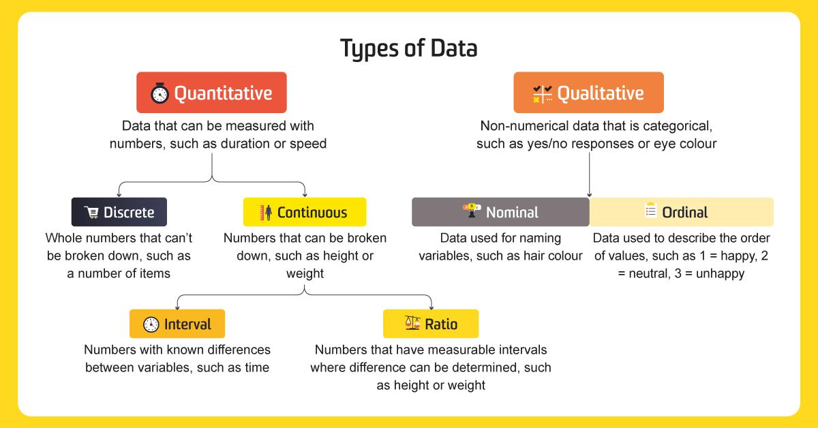
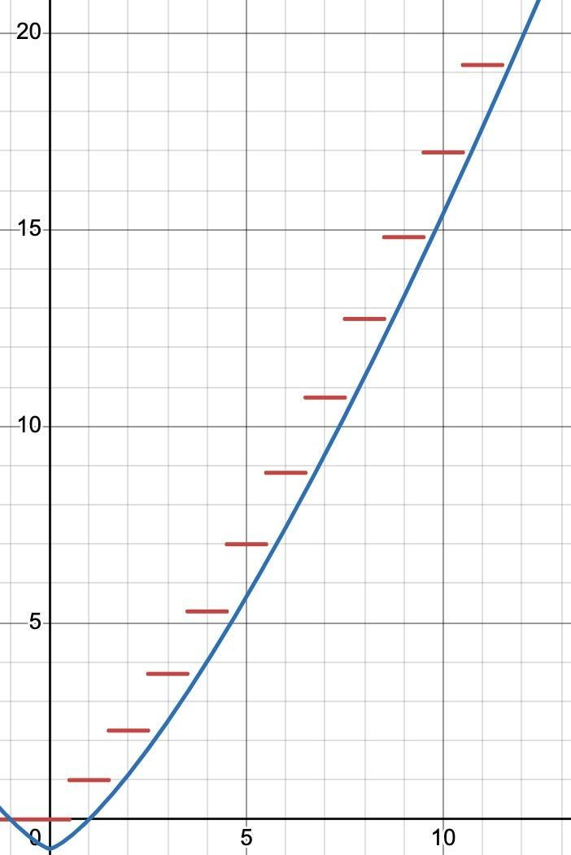

What it means
# Source: AI Source: Provided by: [Data Path: Persons Table -> ID Column: 1, Name_En Column: Motasem Essam] -> From: [ChatGPT] on [4/22/2026]
Continuous data consists of values that can take any number within a range, depending on measurement.

Examples
# Source: AI Source: Provided by: [Data Path: Persons Table -> ID Column: 1, Name_En Column: Motasem Essam] -> From: [ChatGPT] on [4/22/2026]
- Height: 170.2 cm
- Weight: 65.5 kg
- Temperature: 24.7°C
- Time: 12.35 seconds

Type

1. Interval Data (Equal intervals, no true zero)
# Source: AI Source: Provided by: [Data Path: Persons Table -> ID Column: 1, Name_En Column: Motasem Essam] -> From: [ChatGPT] on [4/22/2026]
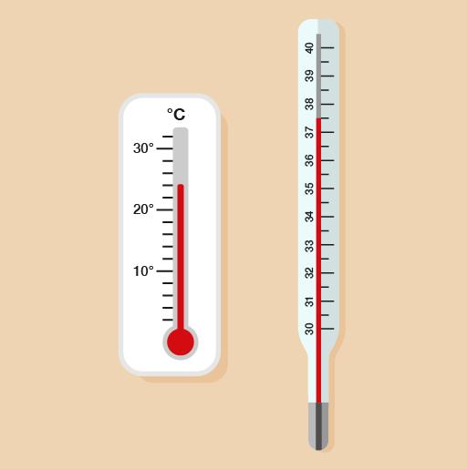
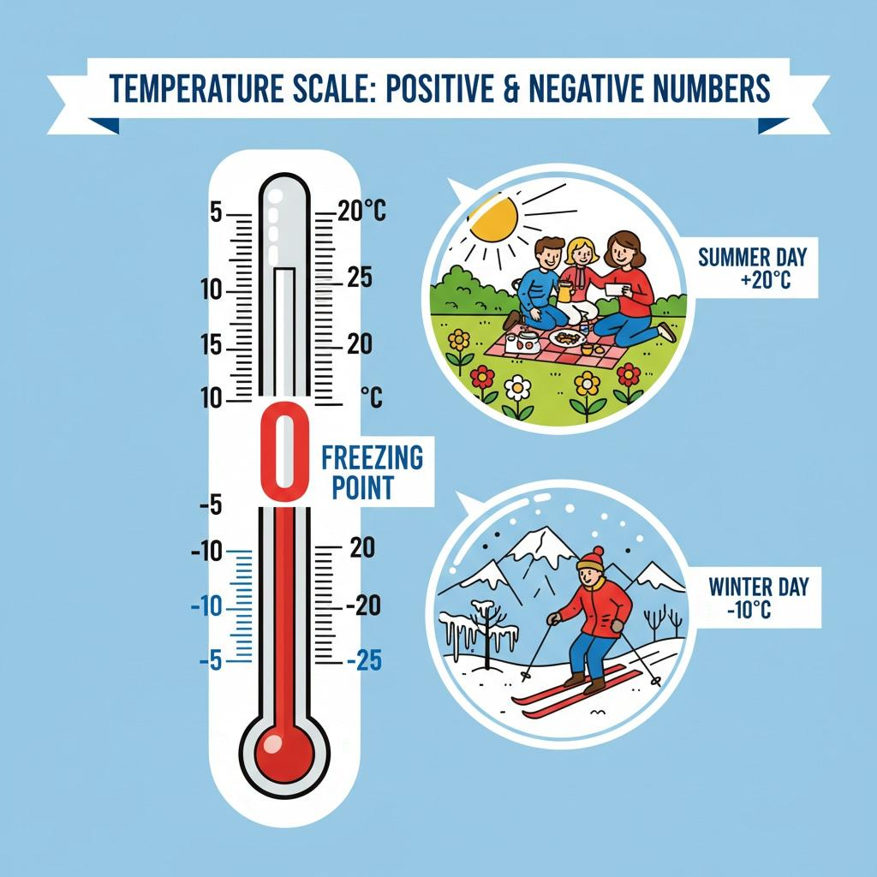
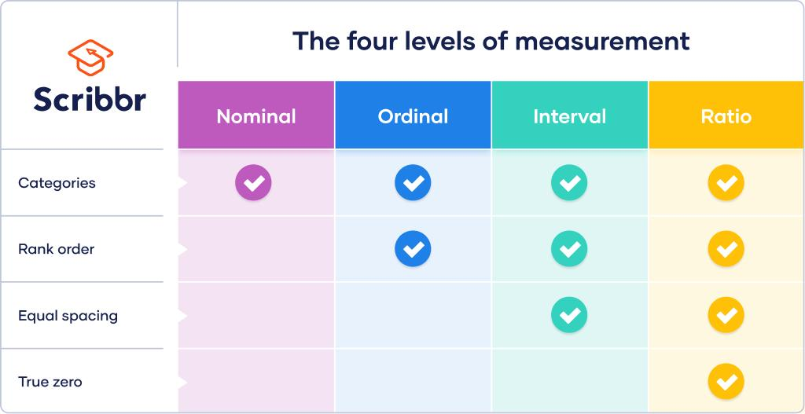

What it means
# Source: AI Source: Provided by: [Data Path: Persons Table -> ID Column: 1, Name_En Column: Motasem Essam] -> From: [ChatGPT] on [4/22/2026]
Interval data is continuous data where:
- The difference between values is meaningful
- But there is no true zero point

Examples
# Source: AI Source: Provided by: [Data Path: Persons Table -> ID Column: 1, Name_En Column: Motasem Essam] -> From: [ChatGPT] on [4/22/2026]
- Temperature in Celsius or Fahrenheit
- Dates (e.g., years: 2000, 2020)

Key features
# Source: AI Source: Provided by: [Data Path: Persons Table -> ID Column: 1, Name_En Column: Motasem Essam] -> From: [ChatGPT] on [4/22/2026]
- You can add and subtract values
- Zero does not mean “nothing” (0°C doesn’t mean no temperature)
- Ratios don’t make sense (40°C is not “twice as hot” as 20°C)

2. Ratio Data (Equal intervals with a true zero)
# Source: AI Source: Provided by: [Data Path: Persons Table -> ID Column: 1, Name_En Column: Motasem Essam] -> From: [ChatGPT] on [4/22/2026]
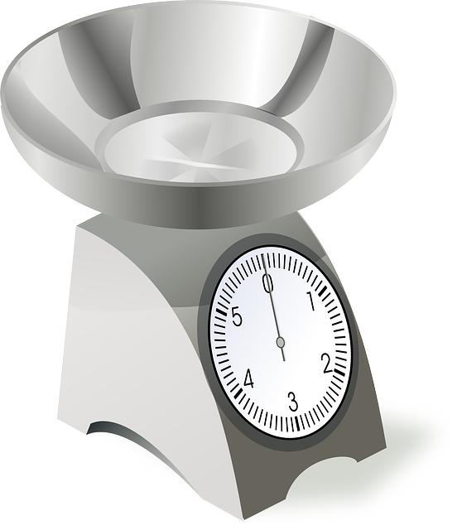
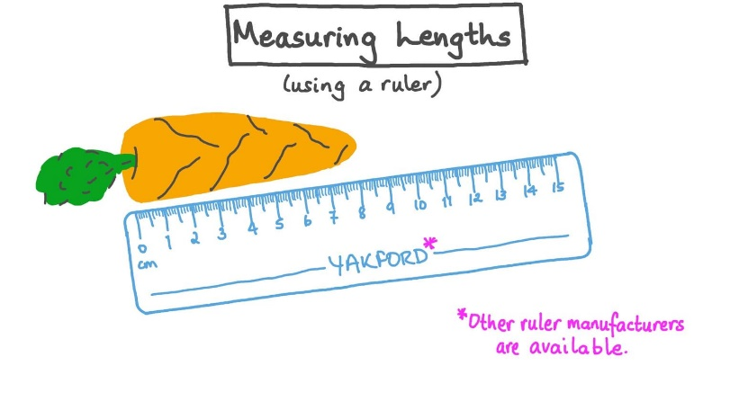
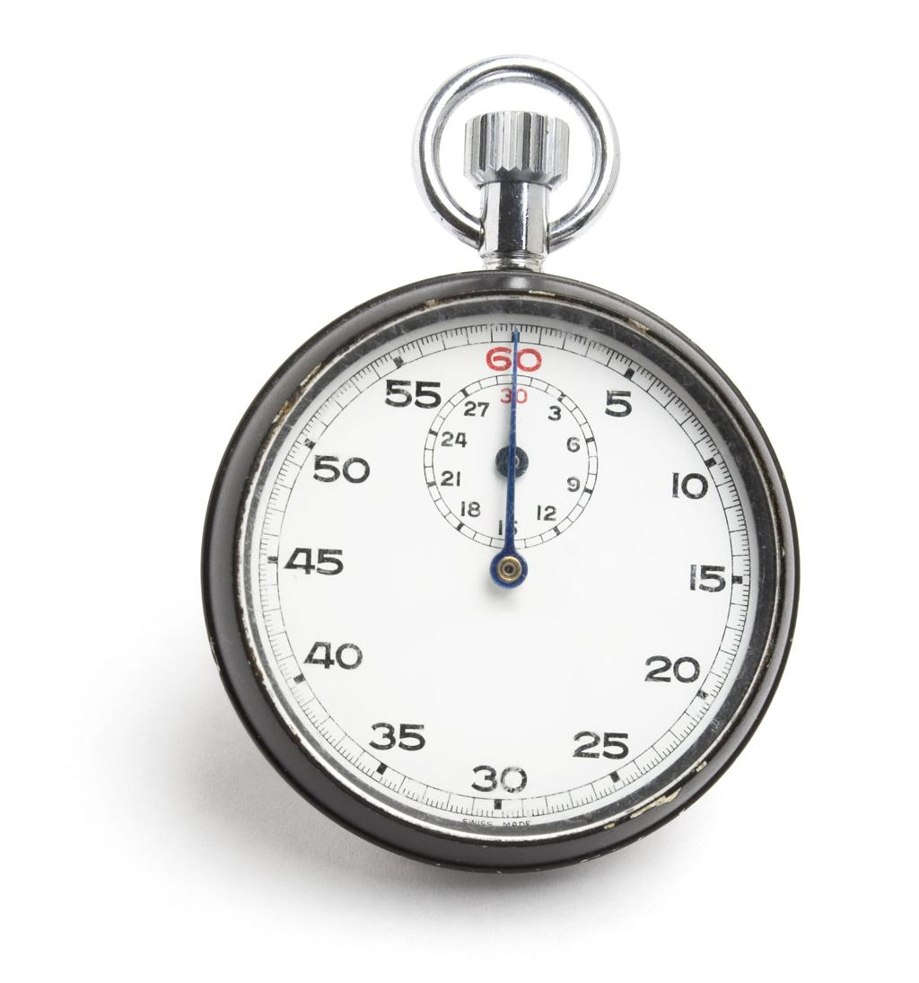

What it means
# Source: AI Source: Provided by: [Data Path: Persons Table -> ID Column: 1, Name_En Column: Motasem Essam] -> From: [ChatGPT] on [4/22/2026]
Ratio data is continuous data where:
- There is a true zero point (means none of the quantity)
- Both differences and ratios are meaningful

Examples
# Source: AI Source: Provided by: [Data Path: Persons Table -> ID Column: 1, Name_En Column: Motasem Essam] -> From: [ChatGPT] on [4/22/2026]
- Height (0 cm means no height)
- Weight (0 kg means no weight)
- Time (0 seconds means no time passed)
- Distance

Key features
# Source: AI Source: Provided by: [Data Path: Persons Table -> ID Column: 1, Name_En Column: Motasem Essam] -> From: [ChatGPT] on [4/22/2026]
- You can add, subtract, multiply, and divide
- Ratios make sense (e.g., 10 kg is twice 5 kg)
- Most real-world measurements fall into this category

Quick summary
# Source: AI Source: Provided by: [Data Path: Persons Table -> ID Column: 1, Name_En Column: Motasem Essam] -> From: [ChatGPT] on [4/22/2026]
- All ratio data is continuous, but not all continuous data is ratio—some (like temperature in °C) is interval.

Main Difference
# Source: AI Source: Provided by: [Data Path: Persons Table -> ID Column: 1, Name_En Column: Motasem Essam] -> From: [ChatGPT] on [4/22/2026]
- Interval data → no true zero (only differences matter)
- Ratio data → true zero (both differences and ratios matter)

Key features
# Source: AI Source: Provided by: [Data Path: Persons Table -> ID Column: 1, Name_En Column: Motasem Essam] -> From: [ChatGPT] on [4/22/2026]
- Can include decimals and fractions
- Values are not limited—they can be as precise as needed
- Comes from measuring
👉 Think of continuous data as things you measure, not count.

Main Difference
# Source: AI Source: Provided by: [Data Path: Persons Table -> ID Column: 1, Name_En Column: Motasem Essam] -> From: [ChatGPT] on [4/22/2026]
- Discrete data → countable, separate values (no decimals)
- Continuous data → measurable, can take any value (including decimals)

Key features
# Source: AI Source: Provided by: [Data Path: Persons Table -> ID Column: 1, Name_En Column: Motasem Essam] -> From: [ChatGPT] on [4/22/2026]
- Always expressed in numbers
- Can be used in calculations (average, sum, etc.)
- Often displayed in graphs and charts

Main Difference (Quick View)
# Source: AI Source: Provided by: [Data Path: Persons Table -> ID Column: 1, Name_En Column: Motasem Essam] -> From: [ChatGPT] on [4/22/2026]
- Qualitative → descriptive (what kind?)
- Quantitative → numerical (how much/how many?)

In computing
# Source: AI Source: Provided by: [Data Path: Persons Table -> ID Column: 1, Name_En Column: Motasem Essam] -> From: [ChatGPT] on [4/22/2026]
Data is what computers store, process, and manipulate to produce useful results (information).

One-line definition
# Source: AI Source: Provided by: [Data Path: Persons Table -> ID Column: 1, Name_En Column: Motasem Essam] -> From: [ChatGPT] on [4/22/2026]
Data is unprocessed facts and figures that can be turned into meaningful information.

